Week 21 – Child Training

Introduction:

This week we will look at some of the specifics associated with training and disciplining our children. Remember, we are not in this alone. God has the ultimate responsibility for raising His children. However, He calls us to do our part.

Use of Discipline

Most parents spend a considerable amount of time trying to find discipline that will produce the desired response. There are no right or wrong ways to discipline a child provided it does not cause injury (which would be classified as abuse). From time to time, spanking can cause bruising and this IS NOT abuse. Slight bruising is sometimes inevitable. Most courts will never say anything to a parent who leaves a bruise on a child's behind that last for less than 4 days. Bruises on the arms, face, torso, and legs are a different story. It may even at times be appropriate to “slap” a mouthy child, however it must never be done with an closed hand or with excessive force. Obviously, if done in anger, the chances of meeting these restrictions is low. The point is, pick types of discipline that are appropriate. Use of corporal punishment is very effective and very appropriate for certain offenses and age groups. Careful thought must be put into each choice, but don't shy away from spankings out of fear. Spankings have their place and should be used at points in every child's life.

Legitimate Use of Chastisement

The use of spanking is not for all offenses. Scripture gives a specific prescription for this act. Terry and Kaye Jackson do an excellent job of outlining this in their book “Parenting With Purpose”. See Appendix I for more details.

Once you understand when and how to use “spanking” to discipline rebellion, the next question becomes at what age is it no longer appropriate. That is a much harder question to answer and in fact I don't believe you can actually put an age on it. My half-sister, age 30, told me a story of how she was “spanked” twice at the age of 17 her step-father. Her step-father was the authority figure in her life since she had lived with him and her mother most of her youth and all her teen years. The rules of behavior and corresponding punishments where well defined. Now as a young adult, she felt the need to “flex” her new muscles and speak disrespectfully to her mother when her request to go to a concert was denied. Her step-father, who had been just listen up to this point, told her that was enough and to meet him in the garage. Once there, she knew what was coming as this was the pattern of her youth. The punishment that followed also obeyed that same pattern, but with the increased vigor due a 17 year old. A similar event occurred later that year when she was caught in the presence of underage alcohol use. Even though she had not consumed, she did nothing to report it either. Therefore she was guilty by association and punished accordingly.

Both of these instances were willful rebellion. At the time, she was humbled and even a little angry. But, she also knew she deserved what she received. Now, a mother of two herself, she is incredibly thankful for a father that loved her enough to not allow her to step outside the line she knew she should have been walking. This is a living example of Proverbs 22:6 - “Train up a child in the way he should go, And when he is old he will not depart from it.” Maintaining consistent behavior as a parent makes or breaks the future of our children. Even when they depart from it from a season, the Truth of their training will bring them back in time.

Behaviors That Destroy Training

There are some behaviors and attitudes that will undermine and ultimately destroy your attempts at training. Conversely, the opposite behaviors will usually help ensure success. Here are a few items to keep in mind.

- Undermining each other's authority – Consistency as a must with training. If parents are not unified in their efforts, the children will learn to play them against each other. If dad gets very upset about something and then mom tells the daughter, “Dad over-reacted, don't worry about it,” she just completely undermined his authority. If dad did over-react, then she needs to discuss that with him behind closed doors and dad must be the one who comes to the child to seek restoration. The same is just as true if the roles are reverse between mom and dad. Parents must never disagree about the training and discipline of the children in front of them. Always stick together. You can always “change your mind” later. In fact, in our home, if my wife has to punish the kids while I'm away, they get it when I get home as well. If they are disrespectful to one, they are disrespectful to both. As the father, it is your responsibility to establish and maintain this rule.
- Allowing ignorance as an excuse – Children eventually learn to ask both parents a question and then pick the answer they like best. Then they blame the parents for not knowing what each other said. This is manipulative behavior and should not be tolerated. My children have been told that if my wife and I give two different answers it is by mistake. That the two of us will never do that purposefully. Therefore if they are given two different answers, it is a mistake and they are to bring it to our attention immediately. Not doing so is deliberate deceit. Deceit is rebellion and will be punished accordingly and sternly.
- Refusal to Punish – There are times where Grace is a useful teaching tool. However, its use must be carefully considered and planned. Grace is never used for rebellion. Not administering due punishment only allows behavior to escalate and ultimately causes more harm to the child as consequences and punishments escalate unnecessarily later to bring the behavior under control. A good analogy for this is leash training a dog. When leash training, a sharp correction is given each time the dog does not obey precise commands. The result is a dog that can eventually be allowed off leash in public with complete control. The controlled dog is a happy dog because he gets to go and do because of his behavior. Contrast that to the dog that is allowed to always pull against the leash. This dog eventually gets resilient enough that he pulls full weight against the restraint, gasping and chocking the entire time. He cannot be taken out in certain places and situations because he is uncontrollable. Results with your children follow the same basic training rules.
- Pride – We all make mistakes. If you allow pride to keep you from admitting them for fear of how you will be perceived (weak or inadequate), you will cause great danger to your relationship with your children and severely undermine your authority. A humble and servant nature is a must. These are not natural and we grow into them. But grow into them we must. These are great teaching moments. Don't miss them.
- Giving Up To Soon – Often, we do not see the results we want in the time frame we expect. The natural response is to assume that they are not working. At times, conditions may even get worse. Just because this happens doesn't mean what we are doing is wrong or ineffective. Behavior changes take time. Attitudes have to change first and the will has to be conquered. Both of these take times. Bad habits and attitudes were not created over night, they don't go away over night either. If you are following God's plan, realize that things will change in God's time as well. Hold fast and be long suffering. If you are truly doing the wrong thing, you will see change and the change will be wrong also. Continuing in the same direction, in most cases, is a more often a test of the will.
- Failure to Train – Discipline is never a substitute for training. Discipline is for rebellion and rebellion alone. The behaviors and attitudes must be taught and cultivated. This takes time, effort, and some creativity. Teaching should be the constant norm. Discipline should become decreasingly rare. (Given the exception of certain “seasons” of trial.)
- Setting Bad Examples – What we live is what we truly believe, not what we say we believe. Children understand this at a fundamental level. Living your life in a way contrary to what you are teaching will sabotage your credibility. We must talked the talk, and absolutely positively walk the walk! Little eyes are watching everything you do. Little ears hear everything you say. And that is what they will do when you aren't around. You'll never be perfect, but always strive to be the model. Even in your failure, teaching can be a success. Children need to see how and be trained to properly deal with failure as well.
- Do Not mistake compliance for acceptance – Be weary of the easily compliant child. You may be blessed with a wonderfully mannered, mature child. Or, you may be being played for a fool. Children are very intellect and resourceful. Many learn to not push back and they will not be monitored as closely. In the void of monitoring, they get into all kinds of issues. By the time the parents learn of their true nature, they are often in way over their heads. Be proactive in monitoring your children – the really goods ones as well as the bad ones. Learn to trust, but always verify that trust is appropriately placed.

Behaviors That Support Training

Just as there are behaviors that destroy your ability to train, there are also behaviors that enhance effective training. Some examples are as follows:

- Consistent, Specific Prayer – As Christians, we cognitively understand the value and importance of prayer. Yet, it seems to be were we turn last when it is where we should turn first. Remember, these are God's children, not ours. If we truly believe that, wouldn't we always seek His guidance first as well as last? As with any prayer, be specific and be continuous. Pray proactively for daily guidance.
- Be Consistent – The more consistent your behavior, the easier things will be on you and your children. Boundaries and exceptions will be clear. Challenges will be minimized. They will know what is expected and expect consequences to be carried out each time. It really does eliminate the pain that comes from constantly “tugging at the leash”.
- Train Deliberately – As part of your homework last week, you developed a list of the behaviors, values, and attitudes you believe your child should acquire. In Appendix III, you will find my list to compare to. Differences in the lists are not right or wrong, simply different based on our own belief systems and maturities. Our lists will change over time. The point is to be deliberate about the implementation. Be ready to not miss opportunities when the occur. But, also plan specific encounters with the purpose of teach as the sole function. Instead of the family vacation to Disney, but go on a Mission Trip to Canada this year as a family. I'd be willing to be that not only would the kids have just as much fun, they will come back with memories that will shape the rest of their lives.
- An Atmosphere of Affirmation – We've already learned that Rules Without Relationship Result in Rebellion. So, we must be proactive in our teaching. If the over-arching mood of your relationship is positive, rebellion will never have a seat. Just as when we studied affirmation with our spouses, affirmation with our children is not simply praise. Affirmation is taking notice of and affirming the behavior, attitudes, and values that our children display that align with those we are trying to teach and value ourselves. Depending on your personality, history, and the seasons of life, finding things to affirm may be difficult. But the more you do it, the easier it gets. No good deed or trait is ever to small to recognize and affirm! Start small and work your way up.
- Develop a Personal Relationship with each Child – Each child is unique and dear. We must take the time to develop individual relationships with each child. In the chaos of life, it is easy to try and do everything as a “family”. When you do, someone will always be starved of the attention they desperately need or get lost in the crowd. Take the time to “date” your children. Each spouse should plan occasional, but regular outings with each child - not just the same gender ones. A father spending an afternoon at the mall with his daughter will show that you are personally interested in her by entering her world. And it will afford you the relationship and opportunity you need to teach those important lessons. The same goes for mothers and sons.
- Expect Immediate Response with No Back-talk – This goes hand in hand with consistency. There are certain areas that are sacred and must not be crossed. This is one of them. Establish the expectation and then maintain it. Ultimately, you get what you accept and you get what you expect. So expect immediate obedience without back-talk and then accept nothing less. Same thing goes of dis-honest. Do not allow it – ever! (Fathers, this is an area where you must step up and be solid. Make sure it is understood that disrespect and dishonest with our wife is disrespect and dishonesty with you. If your children choose this path, they should expect and receive double punishment – one from your wife at the time of occurrence, and one from you when you learn of it later. Be diligent and consistent and this behavior will disappear fast!)
- Healthy Challenges – Hand in hand with #5 is teaching them to learn to challenge you in a health manner. Establish the policy in #5. Then establish rules on how to properly challenge your decisions. Obedience always comes first. Then they can request to challenge you. Make sure you put limits on how often then can do this and the exact protocol to be used. This will improve their communication skills, make them choose wisely in what they challenge, and help them understand that even though there are established rules, Grace and deviation will be afforded when it is reasonable and appropriate. The process would look something like this: You issue a decision. The children makes their intent known that they will obey, but asks if they can challenge your decision. If it meets the rules that you have set forth, the challenge is accepted and they are allowed to present their case. You review their case and if you know see things differently and are inclined to change your mind, then you do just that – you change your mind. A good rule of thumb for a 9 yr olde would be one challenge a week. As they get older and learn to work the process, the number of challenges increase.
- Teach the learning process – As we train our children, we need to teach them how to teach as well. We need to make sure they understand the goal is for all the rules to go away and they be self-ruled internally through God's Grace. How soon they transition from your rules to God's Grace is fully up to them! The more they work at it, the sooner it will come.
- Partner with God – There will be some children who no matter how well their parents did will eventually head off on the wrong path. The is the nature of Free Will. God does not dictate our Will and we should be so glad he doesn't. But, parents who experience this feel like complete failures when they are not. Remember the promises of God in Proverbs 22:6. Even though your child may drift away from your teach and even from God at periods, if you did your part in training them, they will never truly depart. They will eventually come back to it. God is ultimately responsible for saving our children, not us. We have our part, He has His. In the end, it will be Him that draws them to Himself. Hold fast to this knowledge when things don't go the way they “should”.

Wrapping it up

As you can see, parenting is a lot of work. And love is a deliberate act. Be prepared, be diligent, and always keep God at the center. We are give only a few precious years to influence our children in ways that can potentially influence their life decisions for decades. Be the parent now, so that you can be the dear friend later.

Additional Resources

Books:


Parenting With Purpose
By: Terry and Kaye Jackson
Planned release in Jan 2013


Have a New Kid by Friday
By: Dr. Kevin Leman
Revell / 2008 / Hardcover


You Can't Make Me (But I Can Be Persuaded)
**Training Strong Willed Children**
By: Cynthia Ulrich Tobias
Random House, Inc / 1999 / Hardcover

Video Podcasts:

Go to iTunes Store and search for “Raising G-rated kids in a R-rated world” by Westside Family Church in Lenexa, KS. The date range is from 10/3/10 – 11/7/10.
Appendix I

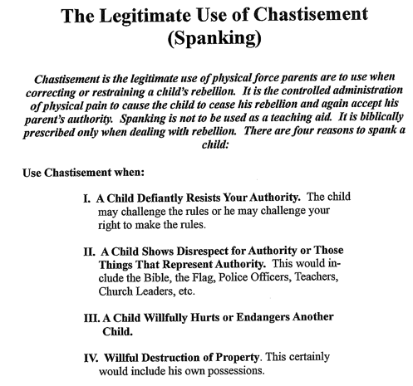

**Exert from “Parenting With Purpose” by Terry and Kaye Jackson, Love Quest Ministries, http://www.lovequestfamilyministries.org

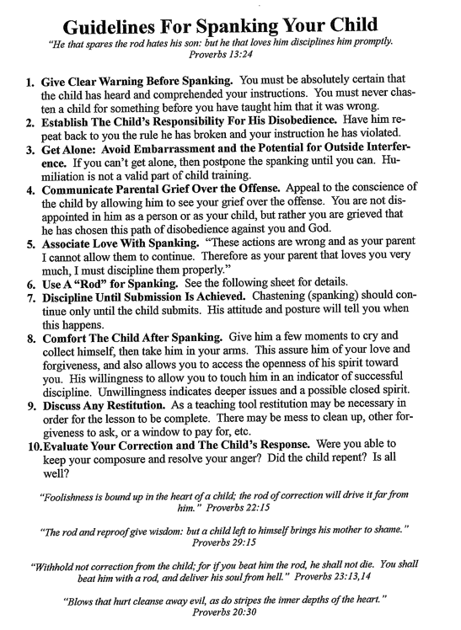

**Exert from “Parenting With Purpose” by Terry and Kaye Jackson, Love Quest Ministries, http://www.lovequestfamilyministries.org

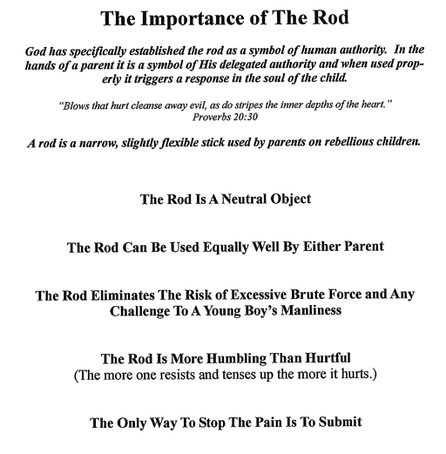

**Exert from “Parenting With Purpose” by Terry and Kaye Jackson, Love Quest Ministries, http://www.lovequestfamilyministries.org
Appendix II



**Exert from “Parenting With Purpose” by Terry and Kaye Jackson, Love Quest Ministries, http://www.lovequestfamilyministries.org
Appendix III

Things to Teach (Ideas, but definitely not exhaustive!):

Fear and Love God
Respect
Mercy
Forgiveness
Repentance
Charity
Sex and Purity
Goal of Marriage
Work Ethic
How to manage money
Basic life skills like laundary, cooking, cleaning, basic home and automotive maintenance
How to Pray
How to study
Humility
To appreciate and value the gifts God has given them
Patience
Honesty
Courage
How to Fail and recover
How to communicate effectively
What anger is and how to deal with it
How to relax/slow down
How to be still and quiet
Basic etiquette

